Ripped Foil - Children

Zeynep Civelek

June 30, 2020

## Exploring the data

The structure of the data is shown below with all the variable names and levels of measurement.

## 'data.frame': 1088 obs. of 15 variables:  
## $ id : Factor w/ 68 levels "14","15","16",..: 1 1 1 1 1 1 1 1 1 1 ...  
## $ age : Factor w/ 3 levels "3","4","5": 3 3 3 3 3 3 3 3 3 3 ...  
## $ agemonths: num 62.9 62.9 62.9 62.9 62.9 ...  
## $ ageyears : num 5.24 5.24 5.24 5.24 5.24 ...  
## $ agecat : Factor w/ 3 levels "five","four",..: 1 1 1 1 1 1 1 1 1 1 ...  
## $ sex : Factor w/ 2 levels "1","2": 1 1 1 1 1 1 1 1 1 1 ...  
## $ order : Factor w/ 2 levels "penfirst","stickerfirst": 1 1 1 1 1 1 1 1 1 1 ...  
## $ boxtype : Factor w/ 2 levels "blue-right","pink-right": 1 1 1 1 1 1 1 1 1 1 ...  
## $ trialtype: Factor w/ 2 levels "pen","sticker": 1 1 1 1 1 1 1 1 2 2 ...  
## $ order2 : int 1 1 1 1 1 1 1 1 2 2 ...  
## $ order3 : Factor w/ 2 levels "test","transfer": 1 1 1 1 1 1 1 1 2 2 ...  
## $ trialno : int 1 2 3 4 5 6 7 8 1 2 ...  
## $ side : Factor w/ 2 levels "L","R": 1 2 2 1 2 1 1 2 2 1 ...  
## $ response : Factor w/ 3 levels "","L","R": 3 2 2 3 2 3 3 2 3 2 ...  
## $ correct : int 1 1 1 1 1 1 1 1 1 1 ...

We decided to use age as a continuous variable (age in months) in our main analyses rather than categorical to have more power.The distribution of age:

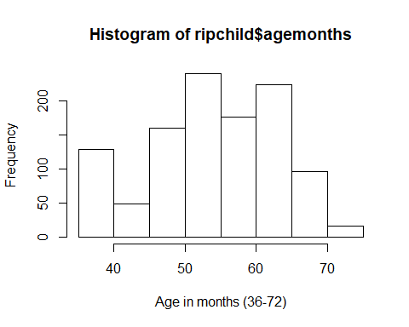

Next I aggregated the trial-by-trial data to create one score per child for Test and Transfer phases as well as an overall score so I can check whether they are normally distributed or not.

## Histograms for Test and Transfer Phases and an overall score (ripchild_individual)

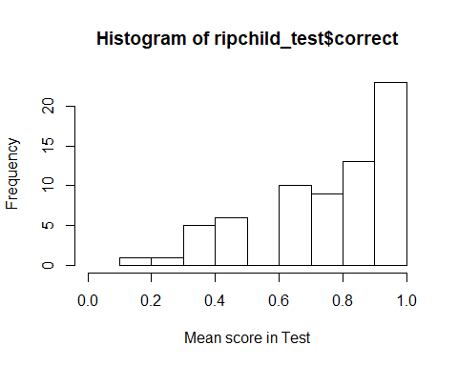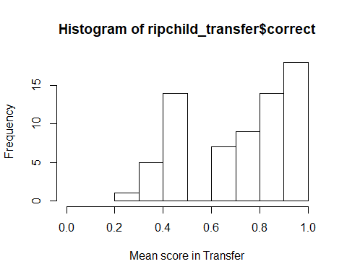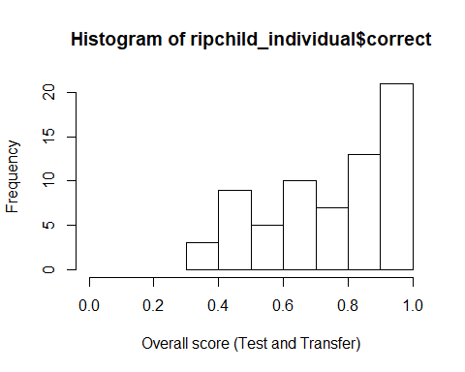

## The tests of normality for Test and Transfer phases as well as for the overall score

##   
## Shapiro-Wilk normality test  
##   
## data: ripchild_individual$correct  
## W = 0.92081, p-value = 0.0003523

##   
## Shapiro-Wilk normality test  
##   
## data: ripchild_test$correct  
## W = 0.86957, p-value = 3.891e-06

##   
## Shapiro-Wilk normality test  
##   
## data: ripchild_transfer$correct  
## W = 0.88645, p-value = 1.522e-05

The Shapiro-Wilk normality tests confirm that the data are not normally distributed for Test and Transfer phases (neither for an overall score).

## Below is the how children in different ages perform in test and transfer.

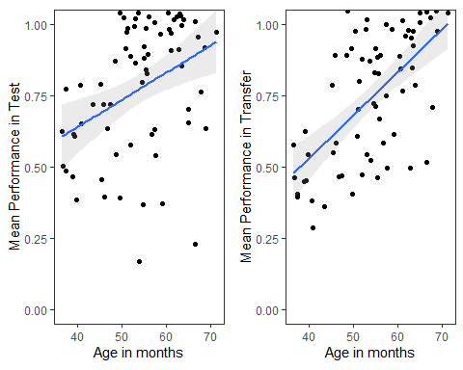

The model prediction (with a 95% CI) for the Transfer phase is steeper than the Test phase. Younger children seem to be doing worse in Transfer than in Test.

## Preparation of the data for running the GLMM

* Z-transformations for 'trial no' and 'age in months'
* Coding dummy variables for trialtype, sex and phase (order3)
* Centering the random slope components for these variables.

## Full model

contr<-glmerControl(optimizer="bobyqa", optCtrl=list(maxfun=10000000))  
full<-glmer(correct ~ trialtype*order3+z.trialno+z.age*order3+sex+(1|id)+(0+z.trialno+order3.transfer.c+trialtype.sticker.c|id),data=ripchild, family=binomial, control=contr)

## boundary (singular) fit: see ?isSingular

The full model does not include box type (the location of the blue/pink box) as a random effect anymore due to convergence issues. But there is a singular fit warning here as you can see.

## Model assumptions

#### Distribution of random effects

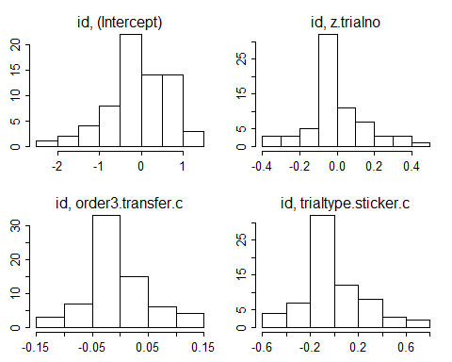

#### Model stability

## [1] "please carefully evaluate whether the result makes sense, and if not, please contact me"

## boundary (singular) fit: see ?isSingular

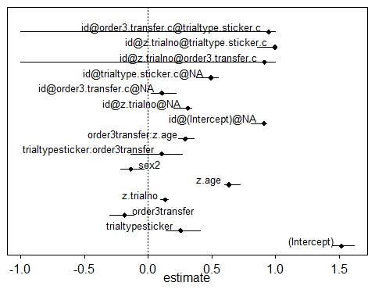

#### Multicollinearity

## trialtype order3 z.trialno z.age   
## 2.004 2.004 1.000 2.021   
## sex trialtype:order3 order3:z.age   
## 1.025 3.011 2.000

#### Overdispersion

## chisq df P dispersion.parameter  
## 1 814.953 1073 1 0.7595088

None of these seem to show a problem- although not sure how to interpret stability. I can provide more info on that.

## Null model

null<-glmer(correct~ 1+(1|id)+(0+z.trialno+order3.transfer.c+trialtype.sticker.c|id),data=ripchild, family=binomial, control=contr)

## boundary (singular) fit: see ?isSingular

## Full and Null comparison

## Data: ripchild  
## Models:  
## null: correct ~ 1 + (1 | id) + (0 + z.trialno + order3.transfer.c +   
## null: trialtype.sticker.c | id)  
## full: correct ~ trialtype * order3 + z.trialno + z.age * order3 + sex +   
## full: (1 | id) + (0 + z.trialno + order3.transfer.c + trialtype.sticker.c |   
## full: id)  
## npar AIC BIC logLik deviance Chisq Df Pr(>Chisq)   
## null 8 1121.8 1161.8 -552.91 1105.8   
## full 15 1100.2 1175.1 -535.09 1070.2 35.646 7 < 2.2e-16 ***  
## ---  
## Signif. codes: 0 '***' 0.001 '**' 0.01 '*' 0.05 '.' 0.1 ' ' 1

The full model is significantly different than the null model.

## Model output

#### Coefficients

## Estimate Std. Error z value Pr(>|z|)  
## (Intercept) 1.517 0.282 5.370 0.000  
## trialtypesticker 0.256 0.335 0.764 0.445  
## order3transfer -0.184 0.329 -0.560 0.576  
## z.trialno 0.135 0.090 1.491 0.136  
## z.age 0.635 0.168 3.772 0.000  
## sex2 -0.135 0.288 -0.468 0.640  
## trialtypesticker:order3transfer 0.108 0.569 0.190 0.849  
## order3transfer:z.age 0.293 0.174 1.685 0.092

#### Individual predictor: Likelihood tests

## Single term deletions  
##   
## Model:  
## correct ~ trialtype * order3 + z.trialno + z.age * order3 + sex +   
## (1 | id) + (0 + z.trialno + order3.transfer.c + trialtype.sticker.c |   
## id)  
## npar AIC LRT Pr(Chi)   
## <none> 1100.2   
## z.trialno 1 1100.4 2.228 0.136   
## sex 1 1098.4 0.218 0.641   
## trialtype:order3 1 1098.2 0.036 0.849   
## order3:z.age 1 1101.1 2.926 0.087 .  
## ---  
## Signif. codes: 0 '***' 0.001 '**' 0.01 '*' 0.05 '.' 0.1 ' ' 1

#### Confidence intervals for the full model with the interaction

## orig X2.5. X97.5.  
## (Intercept) 1.517 0.982 2.102  
## trialtypesticker 0.256 -0.454 0.944  
## order3transfer -0.184 -0.856 0.450  
## z.trialno 0.135 -0.055 0.322  
## z.age 0.635 0.321 0.976  
## sex2 -0.135 -0.718 0.449  
## trialtypesticker:order3transfer 0.108 -1.038 1.296  
## order3transfer:z.age 0.293 -0.047 0.679

**The interactions terms are not significant (although there is a trend for scores to vary by age) so I will remove them from the model.**

## Reduced model without the interactions

## Full model 2

full2=glmer(correct ~ trialtype+order3+z.trialno+z.age+sex+(1|id)+(0+z.trialno+order3.transfer.c+trialtype.sticker.c|id),data=ripchild, family=binomial, control=contr)

## boundary (singular) fit: see ?isSingular

## Null model

null2<-glmer(correct~ 1+(1|id)+(0+z.trialno+order3.transfer.c+trialtype.sticker.c|id),data=ripchild, family=binomial, control=contr)

## boundary (singular) fit: see ?isSingular

#### Full 2 and null comparision

## Data: ripchild  
## Models:  
## null2: correct ~ 1 + (1 | id) + (0 + z.trialno + order3.transfer.c +   
## null2: trialtype.sticker.c | id)  
## full2: correct ~ trialtype + order3 + z.trialno + z.age + sex + (1 |   
## full2: id) + (0 + z.trialno + order3.transfer.c + trialtype.sticker.c |   
## full2: id)  
## npar AIC BIC logLik deviance Chisq Df Pr(>Chisq)   
## null2 8 1121.8 1161.8 -552.91 1105.8   
## full2 13 1099.1 1164.0 -536.57 1073.1 32.692 5 < 2.2e-16 ***  
## ---  
## Signif. codes: 0 '***' 0.001 '**' 0.01 '*' 0.05 '.' 0.1 ' ' 1

Full model is significantly different than the null model.

## Model output

#### Coefficients

## Estimate Std. Error z value Pr(>|z|)  
## (Intercept) 1.540 0.241 6.396 0.000  
## trialtypesticker 0.297 0.176 1.690 0.091  
## order3transfer -0.218 0.172 -1.269 0.205  
## z.trialno 0.137 0.090 1.520 0.129  
## z.age 0.782 0.148 5.299 0.000  
## sex2 -0.129 0.288 -0.450 0.653

#### Individual predictors : Likelihod ratio tests

## Single term deletions  
##   
## Model:  
## correct ~ trialtype + order3 + z.trialno + z.age + sex + (1 |   
## id) + (0 + z.trialno + order3.transfer.c + trialtype.sticker.c |   
## id)  
## npar AIC LRT Pr(Chi)   
## <none> 1099.1   
## trialtype 1 1100.0 2.856 0.091 .   
## order3 1 1098.7 1.605 0.205   
## z.trialno 1 1099.5 2.315 0.128   
## z.age 1 1123.2 26.077 <2e-16 ***  
## sex 1 1097.3 0.202 0.653   
## ---  
## Signif. codes: 0 '***' 0.001 '**' 0.01 '*' 0.05 '.' 0.1 ' ' 1

**Age emerges as a significant predictor of scores.**

#### Confidence intervals for the reduced model without the interaction

## orig X2.5. X97.5.  
## (Intercept) 1.540 1.081 2.026  
## trialtypesticker 0.297 -0.045 0.662  
## order3transfer -0.218 -0.556 0.146  
## z.trialno 0.137 -0.037 0.317  
## z.age 0.782 0.480 1.097  
## sex2 -0.129 -0.685 0.406

#### Calculating effect sizes for the final model

## R2m R2c  
## theoretical 0.13190079 0.3358856  
## delta 0.09146174 0.2329075

Here we look at the row headed delta. Marginal R-squared is the variance explained by the fixed effects and the conditional R-squared is the variance explained by the fixed and random effects (the model).

## Scatterplot 1 to see the effect of age in the overall score.

*Running a separate model for the CI calculation.  
full.CI=glmer(correct ~ z.trialno+order3.transfer.c+trialtype.sticker.c+z.age+sex.m.c+(1+z.trialno+order3.transfer.c+trialtype.sticker.c|id),data=ripchild, family=binomial, control=contr)

*Getting confidence intervals for fitted values

#### Overall performance across age:

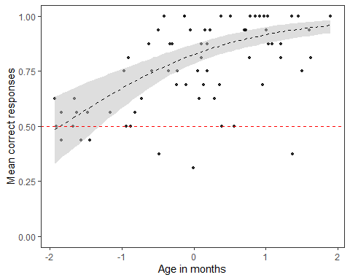

**The plot is not very informative as age in z-transformed. I correct this below.**

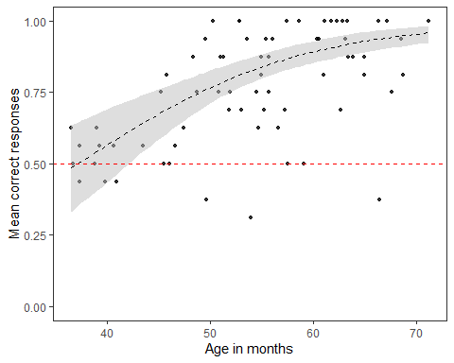

#### Running a new model for calculating CIs for the interaction model so we can plot the performance in test and transfer across ages separately.

full.CI.int<-glmer(correct ~ trialtype.sticker.c+z.age*order3+sex.m.c+z.trialno+(1|id)+(0+z.trialno+order3.transfer.c+trialtype.sticker.c|id),data=ripchild, family=binomial, control=contr)

#### Performance in Test and Transfer across age.

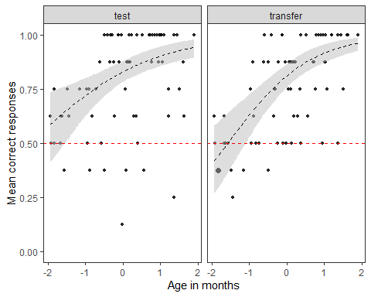

**Once again the age is z-transformed so the plot is not very informative. We change z-age to age in months. I’m providing the code here as something went wrong and the Cis do not cover the whole range of scores. Any ideas about how to fix this?**

ripchild_separate2 <- ripchild %>%  
 group_by(id, agemonths, order3) %>%   
 summarize(correct= mean(correct))%>%  
 ungroup()%>%  
 group_by(agemonths, order3)%>%  
 add_count(correct)

plot.int=seq(from=min(ripchild_separate2$agemonths),  
 to=max(ripchild_separate2$agemonths),length.out=272)  
  
scatter.int2<-ggplot(ripchild_separate2, aes(x=plot.int, y=boot.res.int$ci.predicted$fitted, group=order3)) +  
 geom_point(aes(x=agemonths, y=correct), size=ripchild_separate2$n, alpha=0.8) + facet_wrap(~order3) + geom_ribbon(data=boot.res.int$ci.predicted, aes(x=plot.int, y=boot.res.int$ci.predicted$fitted, ymin=boot.res.int$ci.predicted$lower.cl, ymax=boot.res.int$ci.predicted$upper.cl, group=boot.res.int$ci.predicted$order3),fill="grey", alpha=0.5) + geom_line(data=boot.res.int$ci.predicted, aes(y=boot.res.int$ci.predicted$fitted), lty=2)+  
 theme_bw() + theme(panel.grid.major = element_blank(), panel.grid.minor = element_blank())+ xlab("Age in months")+ ylab("Mean correct responses")+   
 ylim(0,1)+  
 geom_hline(yintercept=0.50, color='red', linetype="dashed")  
   
 scatter.int2

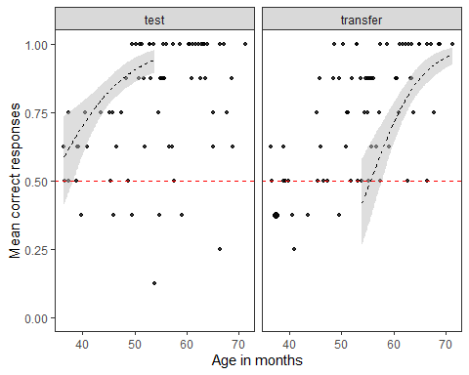

## First trial performance in Transfer phase

We expect younger children to make more errors when they switch from Test to Transfer if they are solving the task using an arbitrary rule (i.e. always pick the first/second ripped cup).

#### Performance in trial 1 of Transfer phase

firsttrial <- glm(correct~agemonths+sex+trialtype,data=ripchild_1st_trial,family=binomial(link = "logit"))  
summary(firsttrial)

## Call:  
## glm(formula = correct ~ agemonths + sex + trialtype, family = binomial(link = "logit"),   
## data = ripchild_1st_trial)  
##   
## Deviance Residuals:   
## Min 1Q Median 3Q Max   
## -2.0658 -1.0328 0.5699 0.8060 1.5530   
##   
## Coefficients:  
## Estimate Std. Error z value Pr(>|z|)   
## (Intercept) -4.36231 1.80644 -2.415 0.01574 *   
## agemonths 0.09633 0.03414 2.822 0.00478 **  
## sex2 -0.02901 0.57703 -0.050 0.95990   
## trialtypesticker 0.22316 0.57090 0.391 0.69588   
## ---  
## Signif. codes: 0 '***' 0.001 '**' 0.01 '*' 0.05 '.' 0.1 ' ' 1  
##   
## (Dispersion parameter for binomial family taken to be 1)  
##   
## Null deviance: 84.069 on 67 degrees of freedom  
## Residual deviance: 74.436 on 64 degrees of freedom  
## AIC: 82.436  
##   
## Number of Fisher Scoring iterations: 4

**Age emerges as a significant predictor of first trial performance of Transfer.**

We can plot this as:

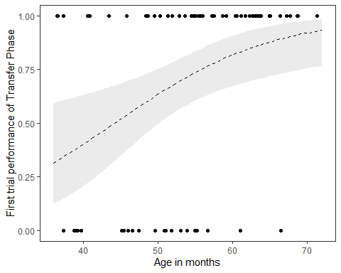

**Younger children tend to make more errors than older children and very few older children make errors in the first switch case.**